Executive Grant of Clemency

DONALD J. TRUMP
President of the United States of America

TO ALL TO WHOM THESE PRESENTS SHALL COME, GREETING:

BE IT KNOWN, THAT THIS DAY, I, DONALD J. TRUMP, PRESIDENT OF THE UNITED STATES, PURSUANT TO MY POWERS UNDER ARTICLE II, SECTION 2, CLAUSE 1, OF THE CONSTITUTION, HAVE GRANTED UNTO

FIRST MIDDLE LAST
ALSO KNOWN AS
"NICKNAME" LAST

A FULL AND UNCONDITIONAL PARDON

FOR THE CONVICTION in the United States District Court for the District of Columbia on an indictment charging violation of Title 21 United States Code (USC) Section 461 Code of Federal Regulations (CFR), Title 9 Section 381.171(d), sentenced on December 18, 2019, to one year, one month and two days of imprisonment and a seven hundred and ﬁfty dollar ($750) ﬁne.

I HEREBY DESIGNATE, direct, and empower the Acting Pardon Attorney, as my representative, to sign a grant of clemency to the person named herein. The Acting Pardon Attorney shall declare that his action is the act of the President, being performed at my direction.

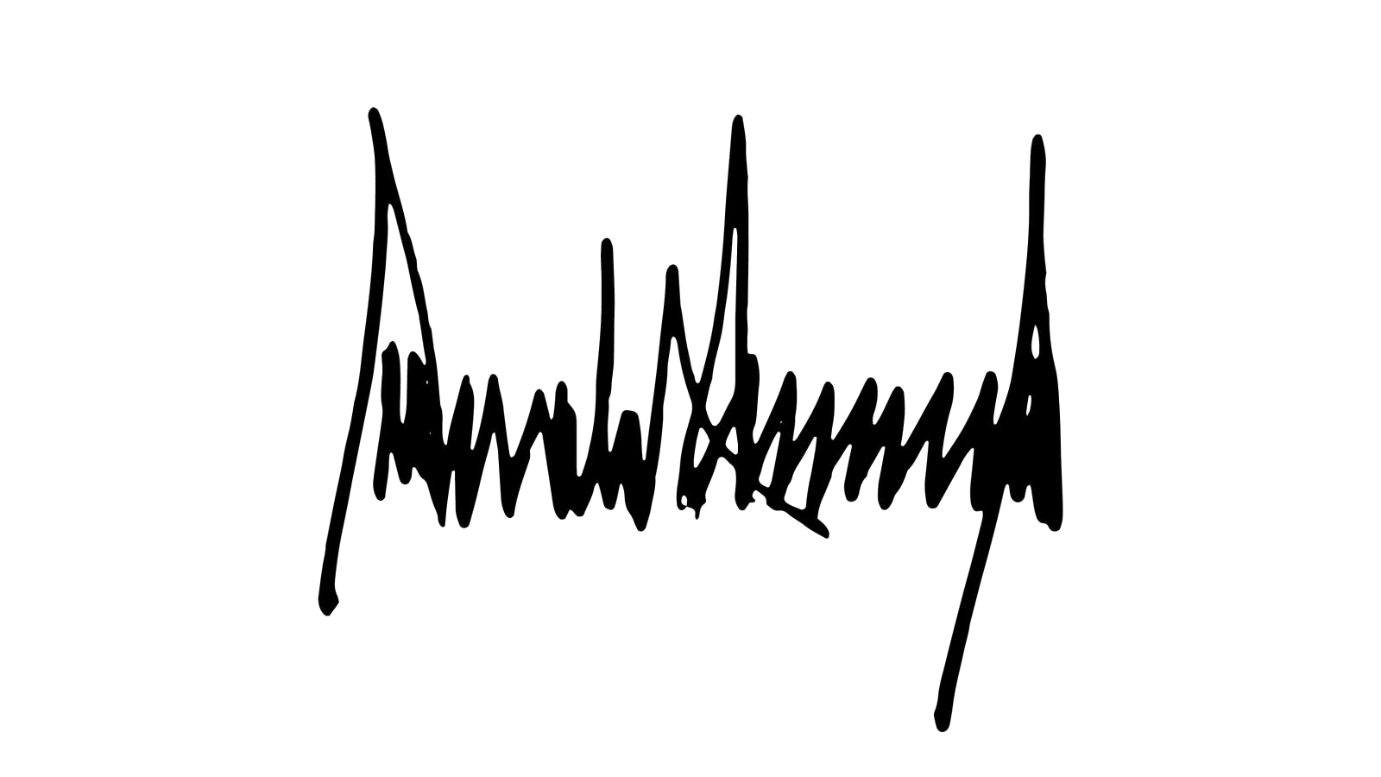
IN TESTIMONY WHEREOF, I have hereunto signed my name and caused the seal of the Department of Justice to be aﬃxed.

Done at the City of Washington this twentieth
day of January in the year of our Lord Two
Thousand and Twenty-one and of the
Independence of the United States the Two
Hundred and Forty-ﬁfth

DONALD J. TRUMP
PRESIDENT

